

**Provisioning Template for SHA 1 to SHA 2 Migration**

**User Guide**

|  |  |  |
| --- | --- | --- |
| **Version** | **Remarks** | **Date** |
| **1.0** | **Provisioning Template User Guide for SHA1 to SHA2 migration** | **20/07/2016** |
| **2.0** | **Updated document with installation of the template.** | **14/02/2017** |
|  |  |  |
|  |  |  |

## Installation of the Template and Helper Script

1. Login to AppViewX.
2. On the left navigation menu, select ***Provisioning***; and click ***Template.***
3. On the upper right portion of the screen click on the  Import button.
4. The following screen will appear. 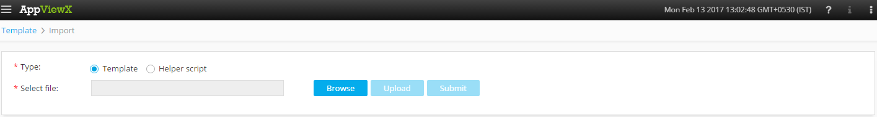
5. Please Select Template/Helper Script.  
   If Template is chosen,
   1. Click on *Browse* and select the Zip File of the template which has to be installed/imported and click open.
   2. Click on upload to import the Zip file and display the templates present in the zip file.
   3. Click on submit to deploy the templates into the AppViewX Environment.

If Helper Script is chosen,

1. Click on *Browse* and select the Zip File of the Helper script which has to be installed/imported and click open.
2. Click on upload to import the Zip file and display the Helper Scripts present in the zip file.
3. Click on submit to deploy the Helper Scripts into the AppViewX Environment.

## SHA1 to SHA2 Bulk Renew

1. Login to AppViewX.
2. On the left navigation menu, select ***Provisioning***; and click ***Request***
3. On the upper right portion of the screen, click the  ***Create*** button.
4. Select the provisioning template name from the list – ‘**SHA1 to SHA2 Bulk Renew**’

**Note:** *If no template is available, this indicates that the user role does not have permission to the requesting template.*

1. Enter the provisioning request description – ‘*Migrate certificates from SHA1 encryption to SHA2*’.
2. Add a default Request scenario name relevant to the template. ***E.g***.: SHA migration of certificates.
3. Enter your ***Username*** and ***Password*** in the relevant fields.

**Note:** *The credentials entered should have the relevant authorized functions for Certificate Renewal.*

1. Click the  fetch button to retrieve the **Roles** based on *username* and *password* entered. Then select the appropriate Role from the **Roles** dropdown.
2. In the **Renew Automatically** field, *Yes* or *No* can be selected based on the necessity to have the certificates renewed automatically by AppViewX.
3. Select the ***Certificate Authority***from the dropdown list.
4. Click the  fetch button to retrieve the **Common name** based on *Certificate Authority* entered. Then select the appropriate ***Common name*** from the list of available common names.
5. Click the  fetch button to retrieve the **Serial Number** based on *Certificate Authority* and *Common name* entered. Then select the appropriate **Serial Number**.
6. Select the appropriate **Issuer** from the list of issuers.
7. Click on  to add the certificate details in to the tabular for SHA1 to SHA2 migration. Multiple certificates can be added in a similar manner to the tabular for SHA1 to SHA2 migration.
8. On selecting a particular certificate entry, click on  to modify the details. Additionally, the certificate entry can be deleted from the tabular by selecting the specific record and clicking on .
9. Click  Button; ensure that the ***Scenario*** is displayed on the right hand pane.
10. Click on ***Submit*** to generate work order(s) for the provisioning request.